ROAD ACCIDENT REPORT SQL QUERIES

Total Casualties


CY Casualties




CY Accidents




CY Fatal Casualties


CY Serious Casualties
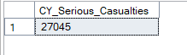

CY Slight Casualties


Secondary KPI
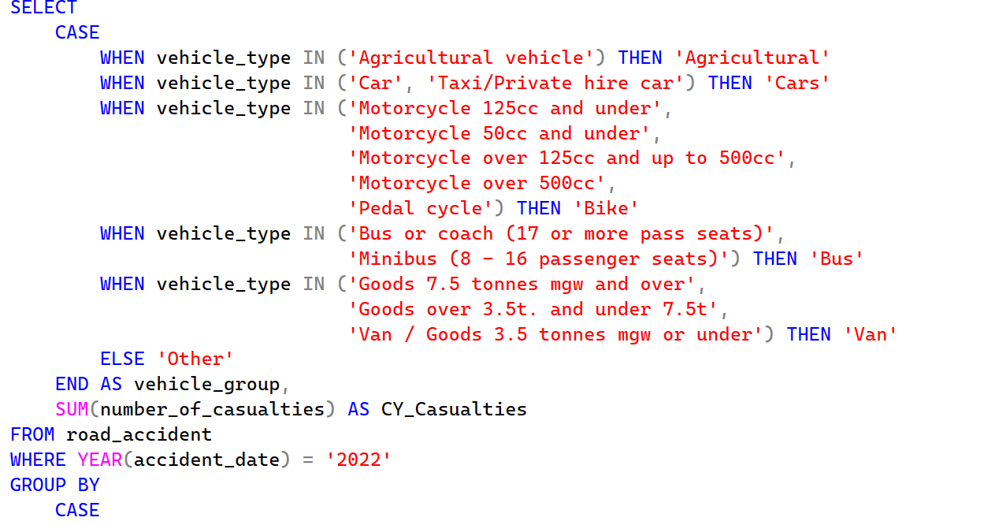
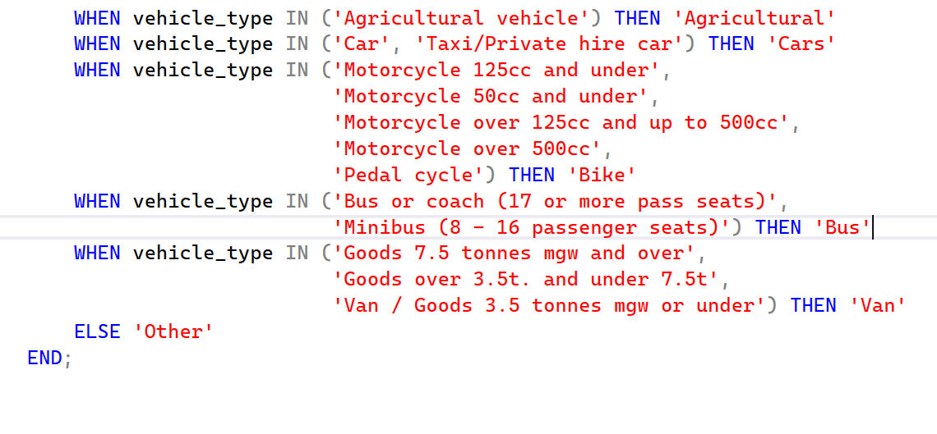
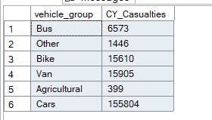
CY Casualties by Month
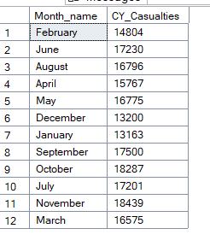

PY Casualties by Month
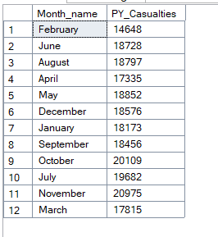
Casualties by Road Type
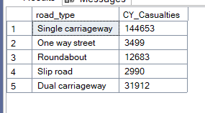

Casualties by Urban / Rural
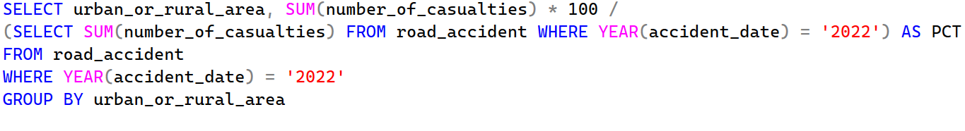
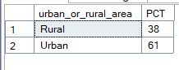

Casualties by Light Condition
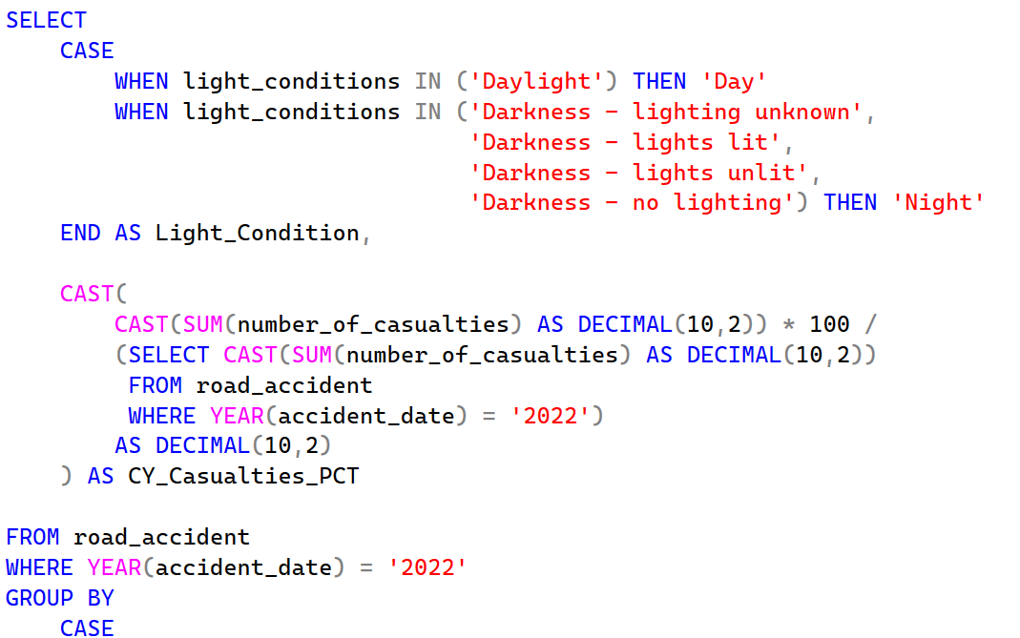
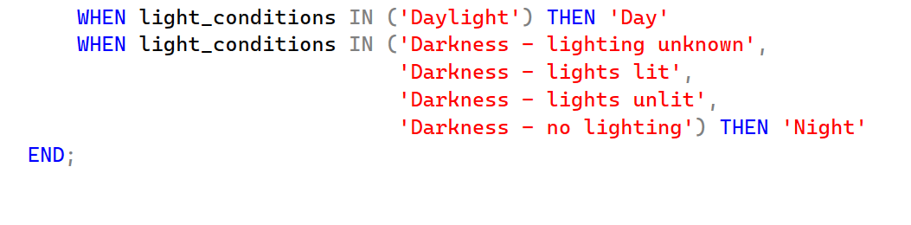
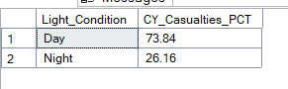

Top 10 Location by No.of Casualties
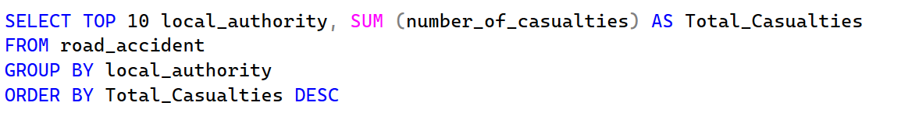
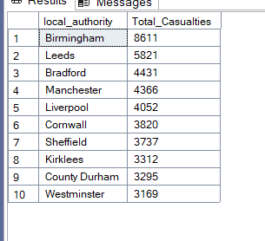
CY Casualties by Road Surface – (using Filter for Dry)
